Standard Operating Procedure for
Determination of Residual Solvents by Gas Chromatography (GC) with Flame Ionization Detector (FID)

SOP-024

February 3, 2015

Front Range Analytical DBA



of
Colorado
4890 Ironton St Unit I
Denver, CO
80239

(303) 375-9533

Contents
Standard Operating Procedure for 0
SOP-024 0
February 3, 2015 0
1.0 Scope and Application 2
2.0 Summary of Method 4
3.0 Definitions 7
4.0 Health and Safety Warnings 7
5.0 Cautions 8
6.0 Interferences 8
7.0 Personnel Qualifications 9
8.0 Apparatus and Materials 10
9.0 Calibration and Standardization 13
10.0 Sample Analysis Procedures 19
11.0 Troubleshooting 20
12.0 System Maintenance 20
13.0 Data Analysis and Calculations 21
14.0 Data and Records Management 23
15.0 Quality Control and Quality Assurance 23
16.0 References 27
17.0 Signature and Revision Page 28

1.0 Scope and Application

In the manufacture of extracts and concentrates of marijuana, solvents (water, butane, carbon dioxide, ethanol, etc.) are used to extract the active ingredients from plant material to produce a resinous, sometimes glassy product.

Common solvents for such extractions include ethanol, water, butane, propane, heptane, hexane and many other commonly available extraction products. Commercially available solvents can be of varying purity. Butane, propane, and other hydrocarbons (pentane, hexane, etc.) in particular, are all derived from petroleum. Petroleum extracted from the ground is a mixture of thousands of compounds.

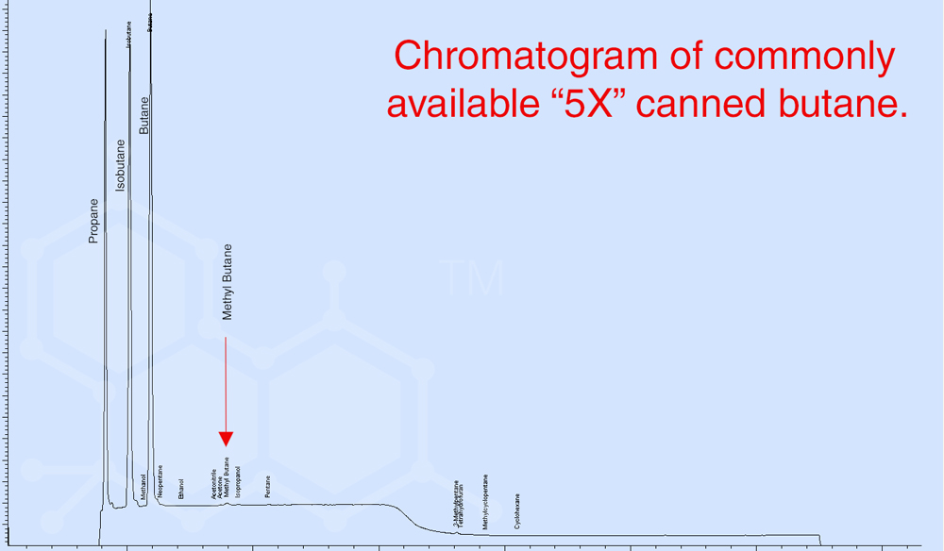

The process of making solvent extracts from raw plant material is typically solvent intensive. Large quantities of solvent are often needed to increase extraction efficiency and to achieve higher levels of purity. After the extraction process is complete, skill and discipline are required to ensure that residual solvents are removed. It is close to impossible to remove ALL residual solvents and the varying experience levels among concentrate manufacturers can significantly impact the efficiency of the purging process. The residual solvents and contamination products carried by these solvents are of critical interest for determination of product safety. Hence specific detection limits are required by CDPHE and a detection limit study has been completed for all CDPHE required compounds as specified by the Wisconsin DNR paper (ref. 2).

Commercial products are available in a wide range purity levels and prices. Various contaminants may be present (e.g. benzene, toluene, xylene, etc.) and these compounds may be more difficult to remove from the sample material.

In addition, many different types of products used to clean the equipment can also be a source of contamination for the resulting concentrate product. These cleaning products include ethanol and acetone and they also carry other unwanted contaminants in the final concentrate. Therefore, while not a CDPHE requirement we have added these compounds to our contaminant list as part of this SOP.

This method provides a procedure for the determination of residual solvents in marijuana concentrates. It specifically targets analytes specified by CDPHE plus some additional compounds of interest to concentrate producers.

The analysis of residual solvents is performed using headspace analysis. In headspace analysis, a auto headspace sampler (Agilent 7697A) is used to obtain a small sample of the gases in the headspace of a sealed vial with the sample preparation. The headspace sample will include vapors of all volatile components in the vial.

The method uses gas chromatography (GC) with flame ionization detection (FID) to identify and quantitate the target analytes.
Refer to SOP 023 with regards to extraction and preparation of samples of marijuana concentrates.
This method provides information with regards to preparation of standards and basic instrument maintenance. Additional information with regards to instrument servicing can be found in the Agilent Headspace Sampler and GC maintenance manuals next to the instrument and/or calling the Agilent technical service at 1-800-227-9770.
The procedure is specifically designed for analysis of dissolved residual solvents from marijuana concentrates. Additional compounds (i.e. other solvents of interest to MED) may be added at a later date.
Detection limits and retention times using this procedure are listed in Table 1. These provide a guide as to expected lower limits of detection. Quantitation limits are determined by the parameters established in Section 9.2 for calibration. Detection limits are validated using detection limit guidance as published by the Wisconsin DNR ¹ as described in Section 9.2. Seven low standards are analyzed and concentrations calculated, the standard deviation of these results are computed and are multiplied by the student’s T value of 3.14. Detection limits studies have only been performed for CDPHE required compounds. Other compounds will incorporate use of quantitation limit.

Table 1. Estimated Detection Limits, Retention Times and Boiling Points
Residual Solvent | Boiling Point (oC) | Estimated Retention Times (min) | Estimated Detection Limits (ug/g)
Propane | -42 | 4.59 | NA
iso -Butane | -11.7 | 5.38 | NA
n-Butane | -1 to 1 | 5.9 | 3.55
Acetone | 56 | 7.2 | NA
Hexane | 68 | 9.38 | 1.38
Ethanol | 78.4 | 6.55 | NA
Benzene | 80.1 | 10.38 | 0.26
Heptane | 98.4 | 10.87 | 5.47
Tolulene | 110.6 | 12.07 | 0.15
Xylenes (m,p) | 138-144 | 13.93 | 0.33/0.26
Xylene (o) | 144 | 14.6 | 0.18
Pentafluorobenzene (PFB) Surrogate | NA | 9.68 | NA
Decane Int Standard | NA | 16.97 | NA

The detection limits for the individual compounds is dependent on the response of the compound compared to the instrument noise using a flame ionization detector (FID). The practical quantitation limit (PQL) is the lowest standard on a 5-point calibration curve meeting specified calibration requirements as noted in Section 9.2.
Detection limits are also provided in Table 1. Procedures for determination of detection limits are described in Section 9.2.
This method is inclusive of data quality indicators (DQIs) or measurement quality objectives (precision, accuracy, detection, and quantitation limits) specific to laboratory attributes. It is intended to provide specific requirements for DQIs such that the user is assured of specific measures or numerical values for each of the DQIs noted above. These values provide a better understanding of methodology limitations as well as method specific quality attributes.

2.0 Summary of Method

The equations describing headspace theory derive from three physical laws associated with vapor pressure, partial pressures, and the relationship between vapor pressure of an analyte above a solution and the concentration of that analyte in solution¹ .
Dalton’s law of partial pressures states that the total pressure of a mixture of ideal gases is equal to the sum of the partial pressures of each gas in the mixture.
Henry’s law for dilute solutions states that at a constant temperature, the amount of a given gas dissolved in a given type and volume of fluid is directly proportional to the partial pressure of that gas at equilibrium with that fluid.
Raoult’s law states that the partial pressure of a solute in the headspace volume is proportional to the mole fraction of the solute in solution.
The concentration of sample analyte in the headspace volume is given by mass balance:

C_{o} V_{L} = C_{G} V_{G} + C_{L} V_{L}
Where:
C_{G} = the concentration of the analyte in the headspace
C_{o} = the concentration of the analyte in the original sample
V_{G} = the volume of gas in the sample vial
V_{L} = the volume of sample
Where:
K is the partition coefficient of: solute in solution/concentration of solute in vapor phase
C_{G} = C_{o} / (K + V_{G}/ V_{L})

The equation shows two important points:
- For consistent results, the ratio V_{G}/ V_{L} must remain constant. This means that the sample volume and vial size need to be kept constant.
The vial size is kept constant through high quality manufacturing of Agilent Headspace Vials. This has been carefully measured and is determined to be 22.3 ml.
The sample amount is weighed and dissolved in DMSO. DMSO was chosen based on literature references² with respect to butane solubility and other contaminants of interest and in addition, DMSO (GC Grade) was found not to contain any of the target contaminants. The total mass of the solvent and sample (a ratio of approximately 6:1) is weighed for each sample. The headspace volume is then normalized based upon the “solvent-sample” volume. The spreadsheet for computing this sample volume is provided as attachment XXX.
- The partition coefficient K is a defined as a constant based upon specific Ideal Gas Properties of the compound of interest, a smaller V_{G}/ V_{L} ratio yields a greater concentration of the compound of interest in the headspace volume. Because K is unknown for the matrix and gases chosen the partition coefficient is kept constant by ensuring samples and standards are prepared in the same matrix (DMSO) and the headspace volume is kept constant and small differences that occur in sample mass from sample to sample are mathematically adjusted to account for variances in headspace volume. This is the purpose of attachment XXX, noted above.

A V_{G}/ V_{L} ratio was chosen such that: 1) ensures headspace volume is constant, 2) it satisfies sample size requirements for the marijuana concentrate industry ensuring sample representativeness and, 3) maintains the ratio of sample to solvent low enough in order to reduce dilution errors.
It should be noted that sample size is critical in order to ensure sample representativeness. Marijuana concentrates are often thought to be homogeneous, however; this is highly dependent on the type of concentrate and manufacturer process. We have determined that the average aliquot of 500mg is usually sufficient in order to obtain a representative concentrate sample. Smaller aliquots than 500mg have proven to be too small to be considered representative for several types of concentrates. In addition, if it is suspected that a concentrate sample is highly inhomogeneous such that a 500mg sample size is not considered representative, then additional sample analyses may be required and an average concentration of each volatile compound of interest would be computed from replicate analyses. This situation, however; is thought to be uncommon and is not part of the standard practice. For this reason replicate analyses could be run in order to better determine concentrate homogeneity. Because testing of marijuana concentrates is a new industry, much of the data needed in order to determine statistical appropriateness of sample size remains unknown.

Compound quantification is performed using FID response. Retention time confirmation is used for compound identification and because there are few solvents of interest with minimal interfering matrices, no other compound identification is required. In addition, retention times are closely monitored and have a variance of less than 0.1 minutes. As noted in Table 1, retention times between compounds of interest is no less than 0.8 minutes and xylenes (o,m,p) are calculated as a total of the m- and p- xylene (elutes at the same R.T.) and o-xylene thereby meeting Colorado DOR requirements.

The following are DOR requirements for concentrate makers:
n-butane < 800 PPM
hexane < 10 PPM
heptane < 500 PPM
benzene < 1 PPM
toluene < 1 PPM
total xylene < 1 PPM

It should also be noted that xylene, while obtained as m-, p-, and o- xylene for purposes of an analytical standard used in analyses, actual xylene concentrations that may be measured in any single sample would be a combination of these three isomers. Therefore, for example if m- or p- xylene were detected (both m- and p- xylene elute at the same retention time), then o-xylene would also be present. In addition, the corollary is true such that if no m- or p- xylene is detected then o-xylene would not be present. This is important in determining actual xylene concentrations in a sample. Because, on occasion it has been noted that there is an interfering compound in DMSO at close to the retention time of o-xylene at very low concentration levels (e.g. less than 0.5 PPM) analyst judgment as to the actual presence of o-xylene is dependent in part on whether or not any m- or p- xylene is also present. This is a common forensic chemistry approach used in determining the presence of suspected compounds. While instrumentation analyses provides evidence of a particular compound actual determination of the presence of that compound is a judgment call made by the analyst based upon several known factors about the sample. In this case, we know that o-xylene is not separated from m- and p- xylene when used in solvents or found as contaminants in other solvents but is separated by elution time in Gas Chromatography. Hence if neither m- nor p-xylene is not present in a sample, then o-xylene would also not be present.

Additional residual solvents are likely to be added to this procedure, as required by MED/DOR and as needed per customer request. As required, appropriate SOP revisions will be instituted.

3.0 Definitions

μL microliter  μm micrometer  CV calibration verification  DQI data quality indicator  FW formula weight  GC gas chromatography  FID flame ionization detector  MDL method detection limit | mg milligram  min minute  mL milliliter  MSDS Material Safety Data Sheet  ng nanogram  nm nanometer  PQL practical quantitation limit  RF response factor  RPD relative percent difference  RSD relative standard deviation

4.0 Health and Safety Warnings

Standard laboratory safety procedures should be employed.
Read and follow precautions as listed in the Material Safety Data Sheets (MSDSs) for the relevant materials
- Hydrogen gas
- Benzene
- Toluene
- Xylene
- Hexane
- DMSO
Because of the nature of DMSO, extra care should be taken when preparing and aliquoting samples. Analysts and technicians are required to use appropriate chemical resistant gloves and eye ware when preparing and aliquoting samples. Spills of any DMSO should be promptly cleaned and excess DMSO must be disposed of as solvent waste. Laboratory solvent waste is a combination of all laboratory solvents and is stored in the appropriate waste container until properly collected and disposed of by an appropriate solvent waste company.
Because the boiling point of DMSO is high and the vapor pressure is low, it is not considered an inhalation hazard. Therefore laboratory analysts and technicians are not required to prepare samples under a fume hood.
Similar precautions should be followed for preparation of BTX and hexane standards. Once prepared, however; standards are used in very small quantities (e.g. matrix spike additions) and hazards are considered to be minimized.

5.0 Cautions

Care should be used when changing gas cylinders for the GC. Cylinders should be kept in the upright position. Cylinders must always be secured with a safety strap. Cylinder movement, when required for changing empty bottles, will require use of a cylinder dolly or carefully rolling cylinder from one location to another maintaining the cylinder in an upright position.

6.0 Interferences

Care should be taken when analyzing chromatograms. Retention times for identified compounds should remain within 0.1 minutes (usually less) in order to ensure the appropriate compounds are identified.
Method interferences can be caused by contaminated solvents, reagents, glassware, and other sample-processing hardware which can lead to discrete artifacts and/or elevated chromatogram baselines. All materials should routinely demonstrate freedom from interferences under analysis conditions by analysis of laboratory blanks. Laboratory blanks consist DMSO sealed in a representative headspace vial (see Section 15.0) Blank analyses are also routinely performed to ensure that compound carry-over is not an issue.
Based on the analysis of several hundred client samples the only compounds which routinely show high concentrations include n-butane, ethanol and acetone. All three of these compounds are highly volatile (see boiling points in Table 1) and no carryover from one sample to the next has ever been noted. Carryover of these three compounds is highly unlikely because of the conditions of the GC run. The final temperature in the GC run is 280 degrees C and held for a sufficient time period in order to ensure carryover is not an issue. No other compounds have been detected in actual samples at high concentrations and are therefore not a concern. If, subsequent sample results show different results, then additional blank analyses will be included in order to ensure carry over is not a problem.

The extent of matrix interferences will be source and matrix specific. If interferences occur in subsequent samples, modification of the gas phase or some additional cleanup may be necessary. Current preparation procedures as specified in SOP 023 must be followed. Procedures have been provided such that matrix interferences are minimized. This has been shown through the addition of matrix spikes as part of the method validation.
Compounds are identified by retention time. Compounds that have similar retention times may co-elute, causing misidentification or inaccurate quantitation. Because of the minimal number of volatile compounds present in marijuana concentrates there are no interfering compounds. This has been validated through the addition of matrix spikes in several different concentrates.
The solvent used for dissolution of concentrate samples is DMSO.
- Acetone quantitation requirements is not specified by MED but is a compound of interest for many clients. Acetone is often present in small quantities in DMSO. Our Acetone quantitation limit is 15 PPM. Acetone concentrations in DMSO have been shown to be less than about 3 PPM (on average). Acetone contamination in DMSO will be monitored over time and the appropriate reporting limit for acetone will be modified as needed.
- All other compounds of interest have not been found in any of the DMSO sources tested.
- In order to ensure contamination is minimized for other potential volatile compounds of interest (e.g. acetone) laboratory extraction precautions have been employed such that all sample preparation is performed when laboratory extractions for marijuana potency have been completed or are performed prior to performing these extractions. Blank experiments with open vials of solvent have shown these precautions to be adequate such that no significant interferences are encountered.
- A consistent source of DMSO has been secured and each new bottle or lot of DMSO is tested prior to being used for sample extraction.
- Smaller bottles of DMSO are opened in order to ensure minimal cross contamination.

7.0 Personnel Qualifications

This method is restricted to use by, or under the supervision of, analysts experienced in the use of chromatography and in the interpretation of chromatograms. Each analyst must demonstrate the ability to generate acceptable results with this method. This is confirmed by analyst training records. The following requirements have been specified for analyst training:
Personnel must have general knowledge of and training and experience in GC operation. They should understand and be familiar with the instrument and software operation manuals.
Personnel must have knowledge of general laboratory safety practices, including appropriate chemical-handling procedures.

Appropriate training will include oversight by the laboratory director and/or supervisory analyst ensuring operations are covered adequately and all identifications are made using appropriate knowledge of: 1) retention time/peak identification, 2) calibration, QC and blank criteria and 3) chemical compound knowledge about the compounds being identified.
The following are the list of training requirements that need to be completed prior to analyst certification for residual solvent analyses:
- Has the analyst been appropriately trained and are they competent to prepare samples for analysis?
- Is the analyst able to properly identify and integrate sample peaks?
- Is the analyst familiar with the GC software and are they able to navigate appropriately through the software program for integration, reporting, storage and sample retrieval?
- Is the analyst familiar with GC basics including gas cylinder, column and other hardware replacement?
- Has analyst oversight been documented such that the analyst has prepared and analyzed a sufficient number of samples and standards as determined by the laboratory lead analyst or director for completing analyses on their own?
- Has the analyst read the SOP and are they able to provide evidence of appropriately understanding and recording all required sample QC?

An appropriate form has been attached to this SOP and will be completed by the appropriate supervisor to ensure adequate training has been completed for all analysts operating instrumentation and performing analysis.

8.0 Apparatus and Materials

8.1 GC Analysis
GC system (Agilent 7890) equipped with a flame ionization detector (FID) and a headspace auto sampler (Agilent 7697) and a ZB-1 column from Phenomenex, or an equivalent column
- Data processors to record, integrate, and store chromatograms
- Auto sampler vials
- Helium carrier gas
- Ultra-pure Air
- Hydrogen

8.3 Required Chemicals
Unless otherwise indicated, all reagents must conform to the specifications established by the Committee on Analytical Reagents of the American Chemical Society. Use the best available grade when such specifications are not available.
- DMSO, GC grade or equivalent

8.4 Calibration Standards
Standard preparation procedures use the following volatile compounds and gases purchased from a reliable supplier such as Matheson Gas and Signma Aldrich. Gases purchased are 99% pure or greater. All other volatile compounds are analytical standards and purchased as pure compounds.
Because these are all pure standards and not a prepared concentration (e.g. Restek standards) all are in pure form hence a second source from another supplier does not seem necessary. Second source standards are more of a check of appropriate concentration and not compound identification. Therefore a single supplier will be used for each compound and a second source check will be the same compound but prepared as a standard by a second analyst. This will serve to verify appropriate instrument calibration.
- Propane (18 L gas cylinder, Matheson Gases)
- Iso-butane (18L gas cylinder, Matheson Gases)
- n-butane (18L gas cylinder, Matheson Gases) - CDPHE required compound
- ethanol (purchased analytical standard, Sigma Aldrich)
- acetone (purchased analytical standard, Sigma Aldrich)
- hexane (purchased analytical standard, Sigma Aldrich) – CDPHE required standard
- benzene (purchased analytical standard, Sigma Aldrich) – CDPHE required standard
- heptane (purchased analytical standard, Sigma Aldrich) – CDPHE required standard
- toluene (purchased analytical standard, Sigma Aldrich) – CDPHE required standard
- decane (purchased analytical standard, Sigma Aldrich) - internal standard
- pentaflourobenzene (purchased analytical standard, Sigma Aldrich) – surrogate standard
- m-, p-, and o-xylene (purchased analytical standard, Sigma Aldrich) – CDPHE required standard. m-and p-xylene cannot be separated by GC and CDPHE only requires that the xylene compounds be quantitated as total xylene. The instrument response area calculated at the elution time for m-and p- xylene will be considered, therefore as a total m- and p- xylene concentration.

8.4.1 Standard Preparation Procedures
Liquid Standards are to be kept refrigerated: <4º C
Compressed gases may be kept at room temperature
Standard Expiration Dates are provided by Supplier

Working standards (as described in the following spreadsheet) should be kept no longer than 6 months and should be kept refrigerated in VOA vials to prevent loss of solvent. Note that DMSO freezes at refrigeration and therefore standards will be required to be thawed prior to use. Thawing of standards should be performed in a warm water bath or at room temperature.

The following approach is used for liquid standards in order to make working standards for calibration and similar concentrations can be used for QC standards. QC standards should be prepared separately by a second analyst as described in Section 8.4.
Make a 2,000 PPM working standard (Label Solution 2,000) for

- Ethanol
- Acetone
- Hexane
- Benzene
- Heptane
- Toluene
- m-xylene
- p-xylene
- o-xylene

Measure approximately 0.03 grams in 15 grams of DMSO. An analytical balance capable of measuring 0.0001 is used for making all standards. Use a 40 ml VOA vial

Label as follows:

YYYYMMDD (date format)
xx-x (page number-letter in Standards Log book; e.g. 38-A)
(compound name e.g benzene)-Solution 2000

Expected standard concentration = 2,000 PPM

- Add standard to vial and record weight
- Add DMSO to vial and record weight
- Record exact concentration in PPM in Log Book (standard mass/total mass of standard + DMSO)

Store working standards in Standard Refrigerator

Using Solution 2,000 for each of the above standards follow the RSA Standards excel spreadsheet for making DMSO standards in order to make a mixed standard used for retention time determination (if needed for making methodology run changes) and calibration standards used for a 5 point calibration curve.

The spreadsheet is designed so that weights of standards are recorded successively and PPM concentrations of the standard will be automatically calculated.

Calculations for determining final PPM concentrations:

- (Mass of the compound/total mass of compound(s) + solvent) x PPM concentration of working standard

The working standard concentration is computed in Section 8.4.1.1.

The following are approximate ranges for the calibration curve following the excel spreadsheet. Exact ranges will be determined by the mass of each compound measured. The attached spreadsheet provides guidance as to the concentrations needed for each calibration point. A calibration curve will be used to cover the ranges noted below. Calibration curve specifications are provided in Section 9.2.

- Acetone, Ethanol and Heptane
(10-2000 PPM)
- Hexane, Toluene, Benzene and m-, p-, o-xylene
(1 – 100 PPM)

The exact standard concentrations should be recorded in the standards log book. The excel spreadsheet is designed so that it can be copied and taped into the log book.

8.4.1.2 Gas Standards
A weighed 25 mL graduated cylinder containing 20 mL of DMSO (ACS grade) is weighed. A Pasteur pipette was clamped with the small end well below the liquid surface and just above the cylinder bottom and a vinyl tube connected to a lecture bottle of (n-butane, propane or iso-butane, see Figure 1). Standard preparation should be performed at room temperature.

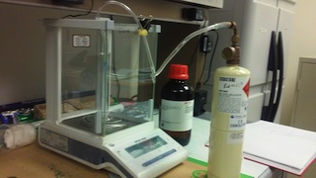
Figure 1. Apparatus for dissolving propane, n-butane and iso-butane in DMSO.

The appropriate gas is passed through the DMSO at a rate of about 1 bubble per second. This is continued for roughly twenty minutes.
The cylinder and contents (DMSO plus specific gas) are weighed and PPM of the standard is calculated as follows:

Mass of gas standard added to solution/total mass of solution + gas standard

PPM = gas standard x 1,000,000

The gas standard solution is poured into a 15 ml screw top glass test tube, such that very little headspace remains in the tube. The objective is to ensure that there is almost no headspace so that while stored, the gas in solution does not partition into the headspace. Once the screw top lid is put on the test tube the tube is inverted and stored upside down so that no gas escapes from the tube. The resulting solution is stored at room temperature.

9.0 Calibration and Standardization

Analytical Conditions for Residual Solvent Analysis
- Column: ZB-1 (Phenomenex or equivalent)
- 60m x 320um x 3um
- Carrier Gas:
- Helium

- The following GC and Headspace parameters were printed from the instrument.

Stored Method on Instrument: 150205_CO_RSA_CERTIFICATION_FINAL

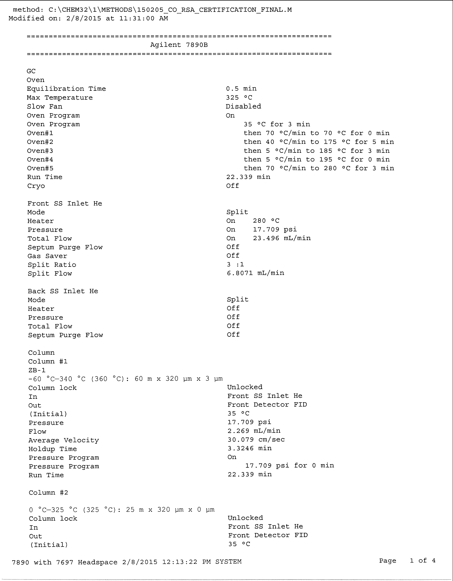
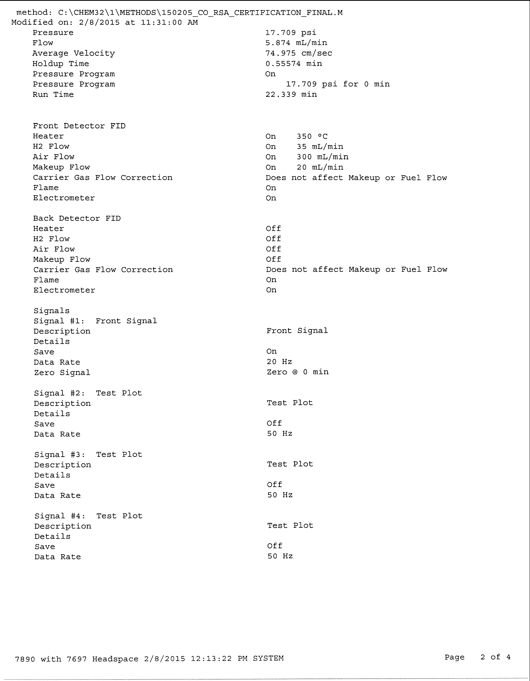
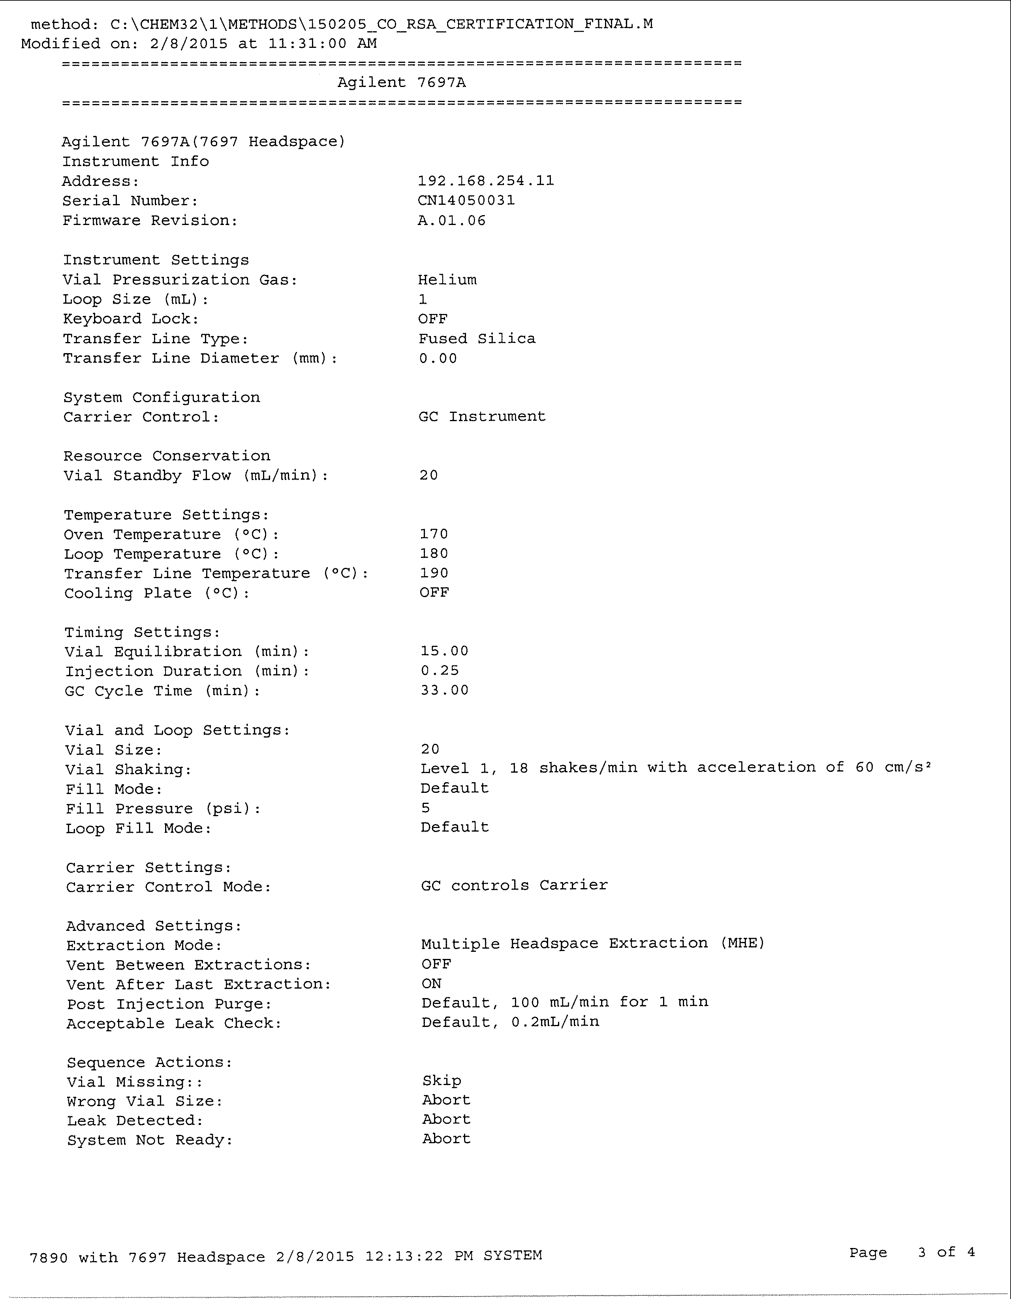

Estimated Retention times for each compound are provided in Table 1.

9.2 Initial Calibration
Perform the calibration before analyzing samples. An initial calibration curve is created for each standard and checked regularly with QC standards as described in Section 15. A new calibration curve is required when LCS or second source standards fail specifications (see Section 15.4) or at least once every 3 to 6 months.

Load calibration standards on the GC-Headspace autosampler from low to high concentrations. Section 8.4.1 provides concentrations to be used for calibration standards. A minimum of 5 calibration standards must be used for each CDPHE required compound. For other compounds a minimum of 5 points must be used with a range factor of 100, a 4 point curve for each compound with a range factor of 50 or a 3 point curve with a range factor of 20 or less and depending upon instrument response and associated linearity; additional standards can be used to cover a wider calibration range if the calibration curve remains linear as defined below. Reported concentrations within the range of the calibration curve are reported without qualification.

Prepare a linear least-squares equation relating the response (area counts) to the calculated analyte concentration (ug/mL):
Area counts = y
ug/mL = x
Calculate the linear correlation coefficient (r²). r² must be > 0.995. Blank values will not be used in the calculation of r². Depending on the concentration requirement, however; some calibration curves can use a “force zero fit” for calculating low concentrations. This is only performed for compounds that are calculated with an instrument response close to the noise level and only used if a standard, close to that level is used in calibration curve. The low standard must meet the requirements specified for the calibration curve, as stated in 9.2.4.
Once the calibration curve is determined each standard concentration used must be calculated using the calibration curve and the percent difference for the calculated value must be within 30% of the true value. If this requirement is not met, the calibration curve must be re-created with appropriate concentration standards.
Higher calibration points will not be used (e.g. 2,000 PPM) for calculation of lower concentrations if the y intercept is skewed significantly from zero. The calibration ranges chosen for each of the compounds are expected to be well within the linear range of the FID.
Retention times for standards and samples should vary by no more than 0.10 minutes. A laboratory control sample (LCS) is prepared from a second source standard as defined in Section 8.4.The LCS is analyzed following the initial calibration. The calculated value (using the calibration curve) of the LCS must fall within a relative percent difference (RPD) of 15% when compared with the concentration.

9.3 Daily Calibration Check
A CV should be run at the beginning of each day’s sample run and repeated with each batch of 20 or less. This standard is prepared separately from those standards used in the calibration curve. A daily high and low point of the calibration curve will also be conducted. The calculated response from the daily analysis of the CV must agree within 20%. If it does not agree, prepare and/or extract an additional CV and re-run the samples. If the CV is still outside the 20% variation, the initial calibration must be repeated.
CV RF for the individual check standards should be within 20% of predicted response.
RFs from daily CVs will be kept in a separate folder for review purposes. Over time a control chart of critical analytes (e.g. n-butane, hexane, heptane, etc.) will be kept in order to track instrument performance.
The daily high and low sample calculation must agree within 30% of the calculated response. If this response is outside this window a second check must be run. If the second check is still outside this window, then re-calibration will be required.
RFs from daily high and low checks will be kept in a separate folder for review purposes. Over time a control chart of critical analytes (e.g. n-butane, hexane, heptane, etc.) will be kept in order to track instrument performance.

10.0 Sample Analysis Procedures

GC/FID Analysis, Overview

A sample aliquot of the gas above the sample is drawn into the injection loop of the instrument. The sample injection loop then injects the sample into the sample transfer line and deposited on the head of the column. The data system is activated simultaneously with sample injection onto the column.
After elution of the final analyte (see chromatogram), data acquisition is terminated and the component concentrations are calculated.
After a stable baseline is achieved, the system can be used for further sample analyses as described above.
Blank samples are needed between samples with high concentration of analytes, if sample carryover is evident.
Initiating Sample Analysis

Enter customer and sample information as follows:

- Open the Sequence Template Tab on Chem Station
- Enter the sample mass in grams and the dilution factor into their appropriate fields
- The sample dilution is calculated based on sample mass and total solvent + sample mass= total mass, after dissolution. Use the attached “multiplier worksheet template” and enter sample mass and total mass in the appropriate columns. The sample multiplier is automatically calculated. This multiplier is computed based on volume of sample and automatically computes for the dilution factor and volume difference in the headspace vial in order to ensure an appropriate correction factor is determined for the change in headspace volume.
- On the sequence template for Chem Station enter the sample number and sample name, Method 141214_CO_RSA, single injection and appropriate internal standard information.
- The multiplier for each sample is based on the calculation from the multiplier worksheet. (see multiplier worksheet attachment)
- Once all information is entered on the Sequence Table open the Sequence Parameters Tab and enter the file name as:

2014xxxx_y
xxxx= month and day
y = the sample run number for the day (i.e. 1, 2, etc.)

- Open the file tab and follow the drop down menu for “save as” and “sequence template” and enter the date as above.
- Once completed ensure the sequence template is saved correctly and the sequence parameter tab saves the appropriate data file. (reference Section 13)
- Open the Sequence Template (now complete) and press the button that says “run sequence”.

The sample sequence will run automatically.

11.0 Troubleshooting

Examine the chromatogram closely to ensure that background peaks are not on the solvent slope of the primary peak such that the compound of interest cannot be quantitated.
(Note: After several cartridge analyses, background buildup on the column may be removed by baking the column at high temperatures (e.g. 300º C.) A bake-out procedure should be conducted, as needed in order to ensure column cleanliness. The frequency of this procedure is dependent upon analyst judgment and if frequent column bake-outs are required then this is an indication that the column should be changed.
If the concentration of analyte exceeds the linear range of the instrument, the sample should be diluted and re-injected.
If the retention time is not duplicated (± 5%), the problem may be associated with the GC flow system. A control chart is recommended to evaluate retention time changes.
For all other problems, see the troubleshooting guide in the operator’s manual.

12.0 System Maintenance

Change the column every 6 months or as indicated by chromatography quality. Column degradation is noted when peak widths become too wide, when R.Ts shift significantly over time, or peak quality is degraded. This will be determined by the supervisory analyst. A change of column requires re-validation of the method. This includes verification and determination of compound retention times, detection limits and compound calibration.
Method verification with respect to matrices (e.g. matrix spikes), is not required when a new column is put in place provided it is the same chemical composition, diameter, pore size and length as the previous column.

Column bake-out may be required if compound carryover persists.
See the operator’s manual for additional system maintenance if problems persist.

13.0 Data Analysis and Calculations

A 3 to 5 point linear calibration is used to calculate a concentration based on instrument response. The requirements for each compound calibration curve are noted in Section 9. Calibration parameters are provided in the method stored on the instrument. Acquisition parameters were provided in Section 9.3. The method file name is provided in this print out and can be referenced for the calibration curves built as part of this method.

13.2 Adjusted Headspace Volume and Dilution using a Multiplier Spreadsheet
An excel spreadsheet is attached to this SOP, which specifies the information needed for inclusion when calculating the adjusted multiplier needed for determining corrected concentrations of target analytes. This correction is automatically performed by the instrumentation software once the appropriate multiplier is added to the instrument run sequence. The purpose of the attached excel spreadsheet is so that this multiplier can be easily calculated knowing the mass of the sample and final mass of the sample diluted in DMSO. Calculations for this spreadsheet are provided below.

- Multiplier for GC Analysis

- Total mass = sample mass + DMSO mass
- Sample mass = mass of aliquot placed in vial
- Dilution Multiplier = 1/(sample mass/total mass)

- Total Headspace Vial Volume = 22.3 ml

- (Headspace vial volume- sample+DMSO volume)/ (Headspace vial volume - standard DMSO volume) = adjusted volume
- 22.3(Headspace sample volume) - 3.0/1.1004(avg. volume of DMSO & std.mix)
- Adjusted volume = (22.3- total sample mass)/1.1004/(22.3-3.0/1.1004)

- Adjusted Result = GC result x dilution multiplier x adjusted volume

13.3 Analytical Data Review
After Sample Run open data in “offline” analysis mode.
Review each sample run and each “target compound” identified by the program and check to ensure the peak was properly integrated.
Changes in peak integration may be required for smaller peaks. Manual peak integration specifications are noted in SOP XXX. In many instances the software will not properly integrate sample peaks and therefore manual peak integration is required.
Peak integrations should be reviewed on a 10 % basis by second analyst. An analyst review checklist which includes a check box for secondary review of the manual integrations is provided as a separate attachment to the SOP.
After Sample Run open data in “offline” analysis mode.
Open report tab and use appropriate report format. Print report as PDF and save on hard disk and on back-up disk.
Data file names are specified in Section 14.3. Instrument acquition parameters and calibration files are tied to these data files by the instrument software. Hence, if for example a sample run was completed on December 16, 2014 and it was the first run of the data the data file would be:
20141216_1
This data file would be found on the instrument under data analysis. Once opened the instrument acquisition parameters (Section 9.3) would reference to the appropriate method file. Method files are catalogued in a similar fashion based on when the method was created. Method files are designated with the date and additional information, as helpful. Hence a method created on December 16, 2014 would be labeled as:

141216_CO_RSA
This file name could include additional helpful indicators such as “draft” or “final” indicating it’s stage of development with appropriate notations in the GC Log Book.

13.3.1 Data Analysis Files.
Data obtained with a specific set of acquisition parameters can be analyzed with the data analysis method of choice, which may or may not be the same name as the data acquisition method. Usually during method development these two method files could be different as noted in the GC Log Book. Once the method is finalized the data acquisition name will be the same as the data analysis acquisition name. Both data analysis and data acquisition are tied to the same method name.

Under normal circumstances the data file will reference the method file, which will include both acquisition and analysis parameters. Therefore calibration curves will be referenced to the data file by the method file name. If data is analyzed using a different method than the data acquisition method, then this must be clearly noted in the G.C. Log for appropriate reference. It is critical that the analyst ensures that data files are clearly tied to calibration used to analyze the data.

Sequence Table Naming.
Each time a sample run is created a sequence table is required. The Sequence Table should be saved and appropriately labled. The naming convention is the same as the Data Analysis naming convention and saved as a Sequence Table. The Sequence Table will verify the order and QC ran with each sample batch. It also logs the Data Acquisition method used but does not specify the data analysis method.

An additional parameter noted in the sequence table is the multiplier used for the analysis based on the dilution factor. As previously noted this multiplier is calculated using the attached spreadsheet which is based on sample mass and total DMSO and sample mass, and automatically corrects for any difference in Headspace Volume. Reference Section 10.2.

Second Analyst Review. A second analyst review should be performed and documented using the attached review checklist in appendix A.

14.0 Data and Records Management

Record data promptly, legibly, and in permanent ink in the instrument logbook and in laboratory notebooks.
Maintain completed laboratory documentation for 2 years.
Data files should be stored on the instrument computer with the following naming convention:
yyyymmdd_1(number sequence used for subsequent batches run on the same day)
Detailed Instructions for data file naming and ensuring data files are tied to the appropriate analysis data and subsequent calibration curves are provided in Section 13.
Store computer-generated data files on two different computers and/or a back up to a hard drive on a weekly basis.
Results will be reported to the client based on FRA reporting requirements using the instrument CSV file.
Sample results are reported between the lowest point and highest point on the calibration curve as unqualified. If sample results are above the highest calibration point these results will be reported to the client as estimated values. Values between the lowest standard (LOQ) and the limit of detection (LOD) as determined by a detection limit study are reported as trace values along with a number. Detection limits are tied to CDPHE requirements for detection of specific compounds. Reporting below these values will simply be reported as less than the determined detection limit.

15.0 Quality Control and Quality Assurance

15.1 Laboratory Blank
A laboratory blank is the measured value of the residual solvents in DMSO used for extraction. A laboratory blank is analyzed at the beginning of each sample run and after every 20 analyses or fewer in order to ensure no column carryover from collected samples. Laboratory blanks should bracket every sample batch. Analyzed compound concentrations in the blank should be no greater than three times less than the lowest calibration standard (i.e., quantitation limit). Specifics regarding laboratory blank requirements are provided in Section 2.7 with specific instructions regarding o-xylene.
Laboratory Blank results must be documented for every sample batch as defined in Section 13.1. Documentation is recorded on a separate form and kept in a laboratory notebook next to the instrument.
Laboratory blank failures will require re-analysis for all samples associated with the batch.
15.2 Compound Concentration Check Standard or Calibration Verification (CV)
A mid-range standard (CV) is prepared separately from the initial calibration standards. The CV is a daily check for calibration verification that is run at the beginning of the analysis and then with every set of 20 or fewer samples. CVs should be close to the values in the analytical batch and vary by no more than 20% of the predicted value when calculated using the RF from the calibration standard.
Laboratory CV results must be documented for every sample batch as defined in Section 13.1. Documentation is recorded on a separate form and kept in a laboratory notebook next to the instrument.
Laboratory CV failures for target analyte(s) will require re-analysis for all samples associated with the batch.
If the second CV fails then a re-calibration will be required for the target analyte(s).
15.3 High/Low Verification
A High and Low laboratory prepared standard will be run with each daily sample run and will challenge both the highest and lowest calibration point for each target analyte. This check must fall within 30% of the calculated value. If values are outside required limits a second high/low check will be run the following day. If this second check is >30% outside the calculated value a new calibration curve will be required for the target analyte(s) failing this check prior to running additional analyses.
Laboratory High/Low results must be documented daily. Documentation is recorded on a separate form and kept in a laboratory notebook next to the instrument.
15.4 Laboratory Control Sample (LCS)
The laboratory control sample (LCS) will also serve as a second source calibration check and will be run after each initial calibration. Specifications for preparation of this sample are provided in Section 8.4. The purpose of the LCS is to ensure the validity of the calibration curve standards. This control sample should vary by no more than 15% (RPD) of the calculated value.
LCS results must be documented following each initial calibration. Documentation is recorded on a separate form and kept in a laboratory notebook next to the instrument.

15.5 Internal Standard
An internal standard will be run with every sample, QC check and calibration. The internal standard chosen is Decane. This is based on the reference discussing micro-extraction techniques ⁶ . Decane elutes well past the target analytes as not to interfere with the analysis.
Internal standards are added after all other sample additions have been completed and just prior to capping the headspace vial.
Internal standard response will be monitored over time. Internal standard response should vary by no more than 50 to 150%.
The response of the internal standard is used to make appropriate corrections in reported concentrations for all target analytes and is calculated by the instrument software.
Internal standards are added at a concentration determined to within an easily identifiable instrument response range and also at a concentration so that 50ul is added to each standard and sample thereby not significantly affecting calculated concentrations.

15.6 Surrogate Standard

The surrogate standard chosen for analysis is pentaflourobenzene. This standard was chosen based on SW-846 Method 8260⁷ and was then tested to ensure no sample or standard interferences were present.
Pentaflourobenzene elutes at a retention time that is approximately in the middle of the run.
It has been tested in sample matrices, blanks and standards and does not have significant interferences.
Internal standard response will be monitored over time. Recovery of the surrogate standard should vary by no more than 25%.
Surrogate standards will be added to every sample and matrix spike. Addition of the surrogate standard should be directly onto the sample or spike matrix, prior to solvent extraction.
Surrogate standards are added at a concentration determined to within an easily identifiable instrument response range and also at a concentration so that 50ul is added to each standard and sample thereby not significantly affecting calculated concentration.

15.7 Detection Limits
An LOD study has been performed for each compound specified by CDPHE. A detection limit study will follow the specifications as noted in the Wisconsin DNR paper (ref. 2). Detection limits are also discussed in Section 1.3.
Detection limits are determined by running a replicate “low” standard 7 times, taking the standard deviation of the calculated results and multiplying by 3.14.
Detection Limit study results must be documented and appropriately stored. Detection Limit studies will be run yearly or if significant instrument repair is required.

15.8 Matrix Spikes
A matrix spike is normally a comparable matrix spiked with the target analytes. (Target analytes are n-butane, hexane, heptane, benzene, toluene, xylenes) For purposes of validation three different matrices where chosen for matrix spiking:

- Shatter
- Concentrate Oil
- Bubble Hash

These are considered different matrices and matrix spike verification studies were conducted as part of the method validation procedure.
Because the sample amount required for each sample is approximately 0.5 grams and because this is a significant sample size for concentrate makers, it was decided that the matrix spike requirement for sample runs would be best satisfied by a surrogate matrix.
As a surrogate matrix a pure, commercially purchased olive oil was chosen. (These data were also supplied as part of the data validation.) Using this surrogate matrix or if available in large enough quantities a client matrix will be used. We will make an effort to use the actual client matrix and only when there is not enough client matrix then we will use a surrogate matrix as a replacement. A matrix spike will be ran with each batch of 20 samples. Samples will be spiked with all target analytes.
Recovery values for matrix spikes will be monitored over time. Because this method is new and no matrix spike information is available, matrix spikes will not have specific recovery requirements.
Recoveries are calculated as follows:
%R = ((spiked sample result-unspiked sample result)/known spike concentration) x 100
Matrix Spike results must be documented daily. Documentation is recorded on a separate form and kept in a laboratory notebook next to the instrument.

15.9 Matrix Spike Duplicates
The same matrix “olive oil or like matrix” will be used for a matrix spike duplicate will be run with every batch of 20 samples. Matrix spike duplicate recoveries will be calculated as a relative percent difference (RPD) and values should be within a 30% RPD. RPDs outside these limits will be appropriately flagged on client reports for samples ran with the defined sample batch.
RPD = spike recovery result-duplicate spike recovery result/ avg. of spike recovery and duplicate spike recovery x 100
Matrix Spike Duplicate results must be documented daily. Documentation is recorded on a separate form and kept in a laboratory notebook next to the instrument.

16.0 References

- Agilent 7697A Headspace Sampler Instrument Manual, Advanced Operation, Agilent Technologies, Inc. 2011. http://www.chem.agilent.com/Library/usermanuals/Public/G4556-90016.pdf
- Analytical Detection Limit Guidance and Laboratory Guide for Determining Method Detection Limits; Wisconsin Department of Natural Resources, Laboratory Certification Program, April 1996. PUBL-TS-056-96
- A Fast, Simple FET Headspace GC-FID Technique for Determining Residual Solvents in Cannabis Concentrates; Corby Hilliard, Amanda Rigdon, William Schroeder, Ph.D.; Christi Schroeder, Ph.D.; and Theo Flood, Restek Corporation, December 2014.
- The Utility of Headspace Grade Solvents in the Analysis of Organic Volatile Impurities; Katherine K. Stenerson and Shyam Verma, Sigma-Aldrich, 2011
- Response Factors for Flame Ionization Detector Operation, Technical Note, Infinicon, 2012
- Preparation of a Solution with a Known Concentration of Sulfur Dioxide in Methanol, Joseph DiVerdi (CSU), 8 October 2010
- Headspace Solvent Microextraction; Theis, AL, Waldack AJ, Hansen SM, Jeannot MA, Anal Chem, December 2001. 73(23):565 1-4.
- Method 8260C; Volatile Organic Compounds by Gas Chromatography/Mass Spectrometry (GC/MS); SW-846 Test Methods/Hazardous Wastes, EPA.
- Chapter One; SW-846 Test Methods/Hazardous Wastes, EPA.

17.0 Signature and Revision Page

Revision Level | Revision Date | Revised By | Brief Description of Revision
1st | 07/07/14 | Joseph Evans | Revision 1

Approved By:

___________________________ ______________
Signature Date

___________________________
Print Name and Title

